

**INTELLIGYM WEBSITE AND APPLICATION**

Prepared by:

**Mohammad Bilal Al-Salahat**

**Abdelrahman Abdallah Basheer**

**Mohannad Ibrahim Jaber**

**Dana Saleem Abu Zenah**

Supervisor By:

**Eng. Nawal Al-Zabin**

**Presented to the Department of Electrical Engineering**

**Computer and Network Engineering**

**At Al-Balqa'a Applied University**

**September, 2023**

# ABSTRACT

For years, health professionals have warned that there is a global obesity epidemic. The difficulty in getting to the gym didn’t make the situation any better. Many people encounter challenges when attempting to join up for a gym membership, especially those who do not stay in one place for a long period of time, such as travelers, tourists, and people whose jobs require them to travel frequently.

Heavy workloads at certain times, the preference for using E-payment, the pressure of mandatory commitment, and the lack of time that makes it feel like a waste of money, are all barriers that face a notable portion of people when they decide to join a gym.

Although some gyms accept E-payments and daily fees, they are often pricey and difficult to locate, so this doesn't completely fix the issue.

Our approach to solve this problem is a platform that is geared toward those who wish to work out in the gym and lead healthier lives without the previously mentioned hassle, by swapping the membership approach for a pay-per-minute one and the possibility of entering any gym nearby.

**INTELLIGYM WEBSITE AND APPLICATION**

By:

**Mohammad Bilal Al-Salahat**

**Abdelrahman Abdallah Basheer**

**Mohannad Ibrahim Jaber**

**Dana Saleem Abu Zenah**

**Approved by:**

**Eng. Nawal Al-Zabin**

**Supervisor:**

**Eng. Nawal Al-Zabin**

# ACKNOWLEDGMENTS

We would like to express our deep and sincere gratitude to our research supervisor, Eng. Nawal Al-Zaben, and Dr. Ahmed Sharadqah, for their valuable and constructive suggestions and guidance during the planning and development of this project. Their willingness to give their time so generously is greatly appreciated. Also, we would like to thank our families and friends for their continued encouragement that made this project possible and for giving us the opportunity to conduct research and providing invaluable guidance throughout this research. Their dynamism, vision, sincerity, and drive inspired us to produce a valuable project. They taught us the methodology for conducting research and presenting the research work as clearly as possible, we are very grateful for what they have given us.

We are also extremely grateful to our parents for their love, prayers, care, and sacrifices to educate us and prepare us for our future.

Finally, our thanks go to all the people who have directly or indirectly supported us to complete the research work.

# DEDICATION

We dedicate this humble project to all our instructors who have supported us throughout our work, especially our supervisor, and of course to our families. We also dedicate this project to our beloved university, and to all the workers there.

# TABLE OF CONTENTS

ABSTRACT I

ACKNOWLEDGMENTS III

DEDICATION IV

TABLE OF CONTENTS V

TABLE OF FIGURE VII

LIST OF TABLES VII

CHAPTER ONE: INTRODUCTION 1

**1.1** **Overviews** 1

**1.2** **Background** 2

**1.3** **Problem Statement** 6

CHAPTER TWO: RELATED WORK 7

**2.1** **ClassPass** 7

**2.2** **Yoma** 8

**2.3** **GetMuv** 10

**2.4** **Comparison With our Work:** 11

CHAPTER THREE: EXPECTRD WORK 13

**3.1** **Proposed Work** 13

3.1.1 Proposed work for Application: 13

3.1.2 Proposed work for website: 16

**3.2** **Deliverables** 18

**3.3** **Functional Requirements:** 19

3.3.1 Functional Requirements for IntelliGym application: 19

3.3.2 Functional Requirements for IntelliGym Website: 21

**3.4** **Non-Functional Requirements:** 23

CHAPTER FOUR: REQUIREMENTS 24

**4.1** **Reactjs:** 24

**4.2** **JSX** 24

**4.3** **Node.js** 25

**4.4** **Flutter** 25

**4.5** **Dart** 26

**4.6** **UI/UX Design Tools** 26

**4.7** **Firebase** 26

**4.8** **API Integration** 26

**4.9** **Testing Frameworks** 27

**4.10** **Performance Optimization** 27

CONCLUSION 28

REFERENCES 29

# TABLE OF FIGURE

Figure 1:ClassPass Website and Application 7

Figure 2:Yoma application 8

Figure 3:GetMuv Application 10

Figure 4: Reactjs advantages 24

Figure 5: JSX 24

Figure 6: Node.js features 25

Figure 7: flutter platform 25

Figure 8: Firebase features 26

# LIST OF TABLES

Table 1: Features of IntelliGym with other 12

# CHAPTER ONE: INTRODUCTION

## **Overviews**

Our platform, IntelliGym, is designed to make the gym-going experience more efficient and convenient for trainees, while also providing a powerful management tool for gym staff, coaches, and nutritionists. The platform is composed of two major parts:

**The mobile application:** This app is designed to simplify the process of getting into the gym and having an efficient session. The app's main feature is a session timer that starts and finishes a session using a QR code scanner, making it easy for trainees to check in and out of the gym. Additionally, the app features a special billing system using Intelicoins, a unique currency to the platform. These coins can be paid for online or at the gym reception desk and can be used for various services within the gym. The app also provides a history of all sessions, which allows users to track their progress and monitor their gym habits. Furthermore, the app includes a leaderboard feature which rewards the top users with discounts on Intellicoins, helping to motivate users to stay active.

**The website:** This aspect of the platform is geared towards gym staff, coaches, and nutritionists, and focuses on management. The website allows users to register as a gym or coach, create posts and announcements, specify costs and information, and purchase ads. This makes it easy for gyms to promote their services, and for coaches and nutritionists to market their skills to potential clients. Additionally, the website provides a powerful set of tools to help gym staff manage their business, from tracking membership numbers to managing employee schedules.

Overall, the IntelliGym platform is a comprehensive solution for both gym trainees and gym staff, providing a range of features to make the gym-going experience more efficient and convenient, while also providing a powerful management tool for gym staff, coaches, and nutritionists.

## **Background**

**The background behind our idea:**

The proliferation of technology in modern society has led to numerous benefits and advancements, however, it has also been associated with various negative consequences. The overuse of technology has been linked to physical and psychological health issues.

On the physical side, a study published in the journal "Applied Ergonomics" observed a correlation between prolonged mobile phone usage and neck or upper back pain in young adults. Furthermore, a study conducted on young adults aged 19-32 years found that individuals who frequently used social media were more than three times as likely to feel socially isolated than those who did not use social media as often.

On the psychological side, research has shown mixed results on the relationship between social media usage and mental health. A systematic review published in 2016 found that people who had more positive interactions and social support on social media platforms had lower levels of depression and anxiety. However, other studies suggest that excessive social media use is associated with increased risk of depression and anxiety. Additionally, using technology too close to bedtime can also disrupt the body's natural circadian rhythm, leading to sleep disturbances.

The overuse of technology also has a sedentary lifestyle effect on people, making them lazy and less active. This can lead to an increase in health problems like obesity and heart disease.

It's important to note that not all the effects of technology overuse are negative, and that the key is to find a balance in technology usage. One way to counteract the negative effects of technology overuse is through regular physical activity and exercise. These activities not only improve physical health but also have a positive impact on mental well-being.

According to guidelines established by the World Health Organization, adults aged 18-64 years should engage in a minimum of 150-300 minutes of moderate-intensity aerobic physical activity, or at least 75-150 minutes of vigorous-intensity aerobic physical activity, or an equivalent combination of moderate- and vigorous-intensity activity throughout the week. In addition, muscle-strengthening activities at moderate or greater intensity that involve all major muscle groups should be performed on 2 or more days a week as they provide additional health benefits. Furthermore, it is recommended to limit the amount of time spent being sedentary and replace it with physical activity of any intensity, including light intensity, to improve overall health. To help reduce the detrimental effects of high levels of sedentary behavior on health, all adults and older adults should aim to do more than the recommended levels of moderate- to vigorous-intensity physical activity.

Regular physical activity is a crucial component of a healthy lifestyle and has been shown to have a wide range of beneficial effects on both physical and mental health. It plays an important role in preventing and managing non-communicable diseases such as cardiovascular diseases, cancer, and diabetes. In addition, regular physical activity has been shown to reduce symptoms of depression and anxiety. Furthermore, physical activity has been shown to enhance cognitive function, including thinking, learning, and judgment skills.

Despite the numerous benefits of physical activity, a significant proportion of the global population does not meet the recommended levels of physical activity. According to the World Health Organization, approximately 25% of adults worldwide do not engage in sufficient levels of physical activity. This lack of physical activity has been associated with an increased risk of death, with individuals who are insufficiently active having a 20-30% increased risk of death compared to those who are sufficiently active. The situation is even more alarming among adolescents, with more than 80% of the world's adolescent population being insufficiently physically active.

In conclusion, regular physical activity is a vital aspect of maintaining overall health and well-being. It can play a critical role in preventing and managing chronic diseases, reducing symptoms of depression and anxiety, and enhancing cognitive function. Despite the numerous benefits of physical activity, a significant proportion of the global population does not meet the recommended levels of physical activity, highlighting the need for increased awareness and efforts to promote physical activity across all age groups.

Our platform aims to make the process of getting into the gym more convenient, which in turn will help more people meet their recommended training times weekly. The platform provides a range of features such as session timers, bill payment system, and reminders to help users stay on track and make the most out of their gym experience. Additionally, it also provides a map feature that shows nearby gyms, allowing users to easily find new gyms to train in, making it easier to reach their recommended training times. By facilitating access to the gym and providing tools to help users stay on track, our platform is designed to help people achieve their recommended levels of physical activity and improve their overall health and well-being.

The traditional gym system can present a number of challenges for individuals who engage in regular travel or experience instability in their lives. One of the major issues is the requirement to register for a minimum period of one month, which can be inflexible for those who frequently travel or move to different locations. Furthermore, individuals who have chronic health conditions that prevent them from being able to attend the gym on consecutive days may also face difficulties in maintaining their gym membership.

To address these challenges, our system employs a new payment system, "pay per minute," which allows individuals to pay for their gym usage on a minute-by-minute basis. This eliminates the need for traditional, long-term registration and allows for greater flexibility in gym usage. Our system also utilizes a QR code scanning system for registration, where the trainee scans the QR code at the gym to start the timer and scans it again when their session is finished.

A healthy diet is essential for the overall well-being of an individual and plays a critical role in preventing malnutrition and a variety of non-communicable diseases (NCDs). However, with the increased production of processed foods, rapid urbanization, and changing lifestyles, there has been a shift in dietary patterns, leading to an increased consumption of foods high in energy, fats, free sugars and salt/sodium, and inadequate intake of fruits, vegetables, and other dietary fibers such as whole grains.

We also understand the importance of a balanced diet in achieving overall health and fitness goals. That is why our app offers consulting services from certified dietitians. These dietitians are experts in the field of food and nutrition and can provide personalized guidance and recommendations based on an individual's specific needs and goals.

Our goal is to provide a supportive environment for individuals looking to lead healthier lives. By offering a gym membership that is tailored to meet the needs and preferences of each individual, we hope to attract new members and keep them engaged in their physical fitness journeys. This, in turn, will allow us to generate more revenue and establish ourselves as the top gym in the area.

Our system employs a unique currency, named Intelicoins, for payments within the application. This allows for greater flexibility in terms of pricing, as the cost per minute may vary between different gyms and allows for the potential for offers and rewards in the future. With this system, trainees can join any gym at any time, without having to worry about long-term registration or inflexible payment systems.

E-payment, also known as electronic payment, refers to the process of making financial transactions through electronic means, E-payment, also known as electronic payment, refers to the process of making financial transactions through electronic means, such as credit cards, debit cards, or mobile payment apps. E-payment is becoming increasingly popular as it offers a number of advantages over traditional payment methods. One of the most significant benefits of e-payment is its convenience. E-payment eliminates the need for physical cash or checks, which can be lost or stolen. Additionally, it allows users to make payments from anywhere and at any time, as long as they have an internet connection.

## **Problem Statement**

The problem that IntelliGym app aims to solve is the lack of accessible and convenient fitness and wellness resources for individuals. Many people struggle to maintain a consistent exercise routine or have limited access to quality gym facilities and nutrition advice. The current options for finding a gym or a personal trainer can be time-consuming, confusing, and overwhelming. Additionally, many people are looking for a more personalized and efficient way to track their fitness progress and receive advice from experts in the field. IntelliGym app aims to address these pain points by providing a comprehensive platform that combines gym facilities and fitness classes with personal training and nutrition services, all in one place and accessible through a mobile app.

# CHAPTER TWO: RELATED WORK

In the development of the gym website and application, it is important to review and consider previous projects and applications that have focused on similar goals. This section provides an overview of some notable related works in the field of gym websites and applications:



## **ClassPass**

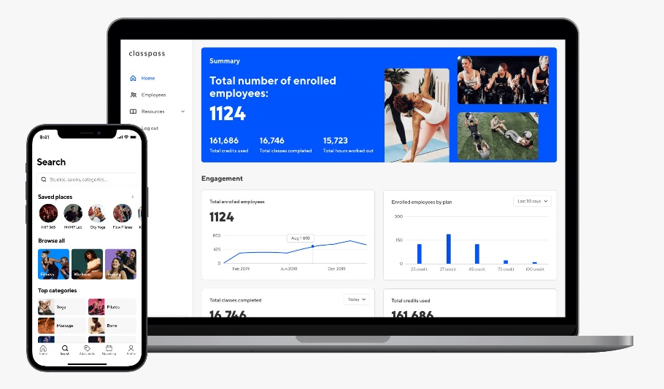ClassPass is revolutionizing the fitness and wellness industry by bringing together the world’s best experiences into one app. their mission to motivate people to live inspired lives every day by introducing and seamlessly connecting them to soul-nurturing experiences. [1]

Figure 1:ClassPass Website and Application



**Features offered of ClassPass:**

* **Affordability:** ClassPass is a more affordable way to try out different fitness classes and studios. You can save money compared to paying for individual classes or memberships.
* **Convenience:** ClassPass is easy to use. You can book classes directly through the app or website, and you can see your upcoming classes and credits in one place.
* **Community:** ClassPass has a vibrant community of fitness enthusiasts. You can connect with other users, get workout advice, and find motivation.
* **Variety:** ClassPass offers a wide variety of fitness classes, including yoga, Pilates, barre, spin, boxing, and more. You can also find classes that focus on specific goals, such as weight loss, strength training, or flexibility.

**Here are some of the cons of ClassPass:**

* **Limited availability:** ClassPass classes can sell out quickly, especially popular ones. You may not always be able to get the class you want, especially if you are on a tight schedule.
* **Hidden fees:** ClassPass charges a monthly membership fee, as well as a booking fee for each class. These fees can add up, especially if you are not using ClassPass very often.
* **No commitment:** ClassPass is a month-to-month membership, so you can cancel at any time. However, if you cancel mid-month, you will lose any unused credits.

## **Yoma**

It provides you with the opportunity to practice various sports and exercises through a large network of sports clubs and a group of distinguished trainers. You can search for dozens of exercises and book in advance through our application simply. [2]

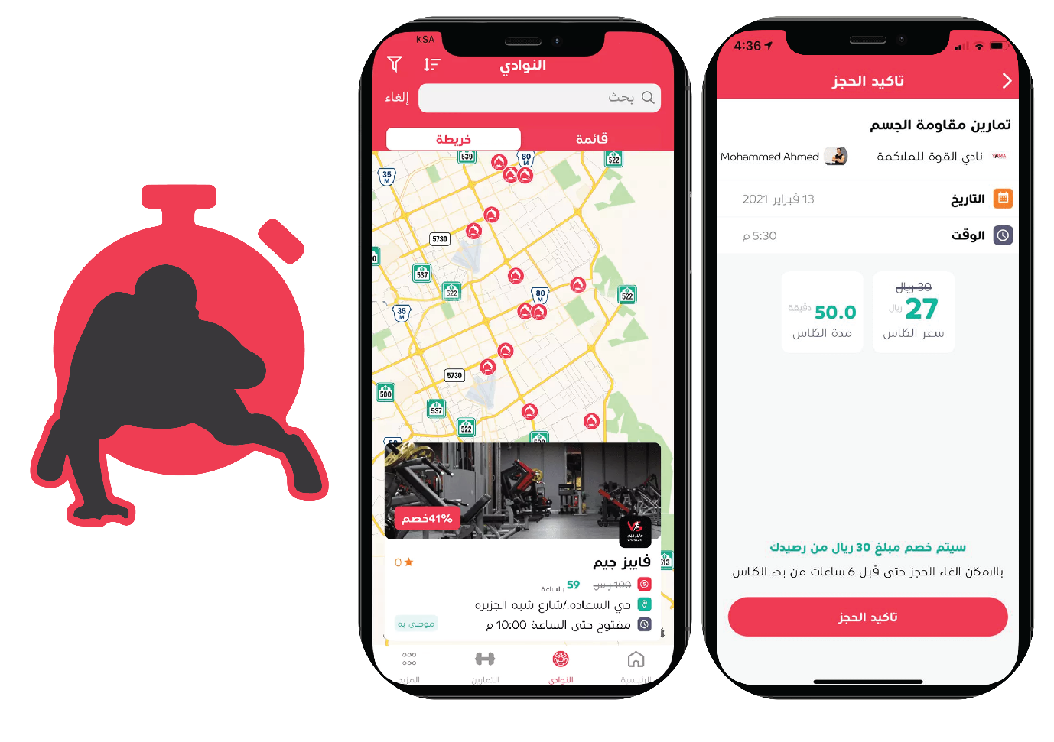

Figure 2:Yoma application

**Features offered of Yoma:**

* **Book gym classes by the minute**: You can book gym classes by the minute, so you only pay for the time you use. This is a great way to save money and only work out when you have time.
* **No long-term contracts or commitments:** There are no long-term contracts or commitments with Yoma, so you can cancel your subscription at any time. This is a great way to try it out without having to worry about being locked in.
* **Easy to use app:** The Yoma app is easy to use and navigate. You can easily find classes, book classes, and track your progress.
* **Safe and secure payments:** Yoma uses safe and secure payments, so you can be confident that your information is protected.
* **To search for gyms**: Users can search for gyms in their area through the Yuma Sports application. The application will provide a list of nearby gyms.

**Here are some of the cons of Yoma:**

* **Limited availability:** Yoma is only available in Saudi Arabia.
* **Limited class selection:** The class selection on Yoma is not as extensive as some other fitness apps.
* **Peak time surcharges:** Yoma charges a surcharge for classes during peak times, such as weekdays during the workday.
* **No cancellation policy:** There is no cancellation policy with Yoma, so you will be charged for any classes that you book, even if you don't show up.
* **Technical difficulties:** There have been some reports of technical difficulties with the Yoma app.

The application does not contain nutrition experts, nor does it contain evaluation of coaches and gymnasiums, and it does not support the feature. The application does not contain nutrition experts, nor does it contain evaluation of coaches and gymnasiums, and it does not support the feature of direct communication with coaches and nutrition experts. of direct communication with coaches and nutrition experts

## **GetMuv**

GetMuv is a good app for users who are looking for an easy way to book gym classes at different gyms in Saudi Arabia. The app provides a range of features that make it easy for users to find suitable gym classes, book them, and track their training progress. [3]

 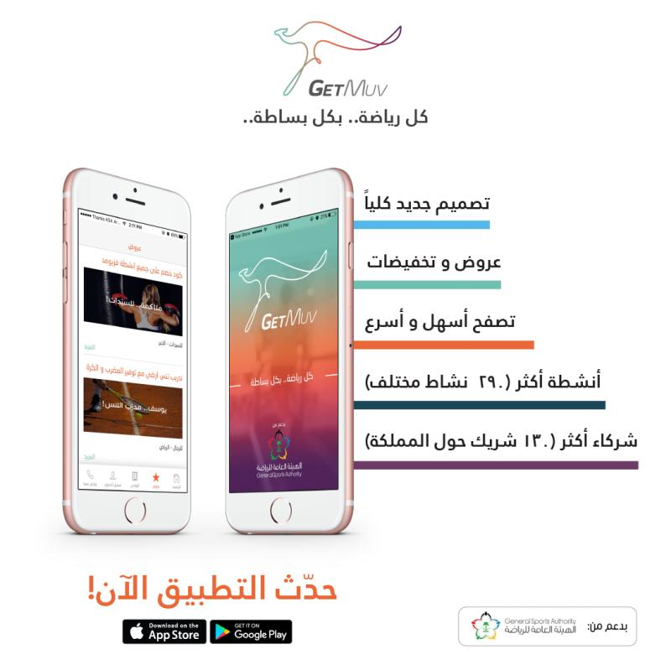

Figure 3:GetMuv Application

**Features offered of GetMuv:**

* **To search for sports and sports centers:** Users can search for different types of sports and sports centers in their area through the GetMuv application. The app will provide a list of nearby sports and fitness centres, including contact information, address and opening hours.
* **Booking sports classes**: Users can book sports classes in different sports centers through the GetMuv application. The application will provide a list of available trainers, as well as information about their experience and specializations.
* **Track Training Progress:** Users can track their training progress through the GetMuv app. The application will provide a record of the exercises performed, as well as comments and tips from the trainers.

**Here are some of the cons of GetMuv:**

* **Price:** The prices of some sports classes in the application may be relatively high. For example, a yoga class might cost 100 SAR.
* **Inaccurate Reviews:** Some reviews and comments posted on the app may be inaccurate or subjective. For example, users may leave negative ratings or comments about a particular gym or trainer based on a single bad experience.
* **Customer support is not always available**: Customer support in the app may not always be available, especially during peak times. Users may have difficulty contacting the customer support team if they face any issues with the app.

## **Comparison With our Work:**

**IntelliGym**

* Aims to revolutionize the fitness industry by providing a comprehensive and convenient platform for users to track their progress, connect with top coaches and nutritionists, and stay on top of their fitness goals.
* Offers innovative features such as QR code scanning, real-time session tracking, and a directory of nearby gyms.
* Focuses on security and ease of use.
* Provides a unique and valuable solution for the modern fitness enthusiast.

**Other fitness apps**

* Typically offer a limited set of features, such as tracking workouts and providing workout plans.
* May not be as secure or easy to use as IntelliGym.
* May not offer the same level of personalization or community support as IntelliGym.

**Here are some specific ways in which IntelliGym stands out from other fitness apps:**

* **QR code scanning:** IntelliGym users can scan QR codes at gyms to automatically check in and start tracking their workout. This is a more convenient and efficient way to track workouts than manually entering the gym name and location.
* **Real-time session tracking:** IntelliGym users can track their workouts in real time, including the number of calories burned, distance traveled, and heart rate. This data can be used to track progress and make adjustments to workouts as needed.
* **Directory of nearby gyms:**IntelliGym users can easily find nearby gyms that offer the classes and amenities they are looking for. This is a great way to find a gym that is convenient and fits their needs.
* **Personalization:** IntelliGym uses data from user workouts to create personalized workout plans and recommendations. This helps users stay on track and achieve their fitness goals.
* Community support: IntelliGym users can connect with other users and coaches to get support and motivation. This can be a valuable resource for people who are new to fitness or who are trying to reach a specific goal.

Table 1: Features of IntelliGym with other

|  |  |  |
| --- | --- | --- |
| **Feature** | **IntelliGym** | **Other** |
| **Affordability** | Book gym classes by the minute, so you only pay for the time you use. | Varies depending on the features and services used. |
| **Convenience** | Easy to use app with a variety of features. | Easy to use and navigate. |
| **Community** | Users can connect with Nutrition experts and coaches to get support and motivation. | No community features. |
| **Personalization** | Uses data from user workouts to create personalized workout plans and recommendations. | No personalization features. |
| **Security** | Uses state-of-the-art security measures to protect user data. | Safe and secure payments. |
| **Availability** | Available in All country | Only available in Specific countries |

# CHAPTER THREE: EXPECTRD WORK



## **Proposed Work**

### Proposed work for Application:

**login**

The IntelliGym mobile application serves as the primary portal for clients to access the app and its offerings. This page has been designed with comprehensive authentication and security measures to ensure the confidentiality and protection of client data.

The interface typically includes two fields: a username field and a password field. Users enter their username and password in the respective fields and then click on a button to log in.

When a user enters their username and password into the login interface and clicks the login button, the application sends the username and password to the application server for authentication. If the username and password are valid, the application server grants the user access to the application.

**Sign up.**

The application signs up interface that contains a username field, an email address field, a password field, and password configuration options:

* **Username:** The username is a unique identifier for the user. It is typically a string of characters, but it may also be an email address or another type of identifier. The username should be easy to remember and type, but it should also be unique enough to prevent other users from choosing the same username.
* **Email address:** The email address is used to verify the user's identity and to send them important account information, such as password reset instructions. The email address should be a valid email address that the user has access to.
* **Password:** The password is a secret string that the user uses to authenticate themselves to the application. The password should be at least 8 characters long and should include a mix of uppercase and lowercase letters, numbers, and symbols. The password should be difficult to guess, but it should also be easy for the user to remember.
* **Password configuration:** Retype the password again to confirm it
* **Create account:** When a user signs up for an application, they will typically be required to enter all of the information in the sign-up interface. The application will then verify the user's information and create an account for them. The user will then be able to log in to the application using their username and password.

**Forget password.**

The forget password interface is a user interface that allows users to reset their passwords when they have forgotten them. The interface typically consists of a field for the user to enter their email address, and a button to send a password reset link to the user's email address.

When the user clicks the "send link to your email" button, the application sends a password reset link to the user's email address. The password reset link contains a unique code that the user can use to reset their password.

To reset their password, the user clicks on the password reset link in their email. The link will take them to a password reset page where they can enter their new password. The user will then be able to log in to the application using their new password.

**Dashboard**

The dashboard interface is the main screen of the application that users see after they log in. It typically contains your profile at the top of screen and a search bar that users can use to search for nearby gyms.

The dashboard may also include categories of popular coaches and nutrition.

When you find a nearby gym, its name, rating, and location will appear to you, and you can know its status open or closed, working hours, days, and communication with the gym.

And we can see the profile of the coaches, his working hours in the gym, his rating, and his private accounts to communicate with him.

**Notifications**The Notifications page, accessible from the bottom navigation bar, displays read and unread notifications in a clear and intuitive manner. Users can quickly identify the status of their notifications, ensuring that they stay informed and up to date on important updates from the IntelliGym app. The page provides an organized and user-friendly way to manage notifications, helping users to stay in the loop without feeling overwhelmed by excess information.

**Profile**

The profile page of the IntelliGym mobile application is designed to offer users easy access to their personal information and settings within the app. The page features the user's name and email, providing a comprehensive overview of the user's profile. The page includes a range of buttons and links that allow users to modify their profile settings.

**Coaches and nutritionists’ screens**

The Coaches and Nutritionists screens within the IntelliGym app provide detailed information about individual coaches and nutritionists. These screens display their status, ratings, and availability in terms of scheduling. Users can also easily contact these professionals, as well as view and write reviews about their experiences. This allows users to make informed decisions about which coaches and nutritionists are best suited to meet their needs.

**Scan QR code**

The QR Scanner is a feature in the IntelliGym mobile application that allows users to easily track and record their gym sessions. This is a button that the user clicks to scan the QR code. When the user clicks the scan button, the camera preview will be activated, and the user will be able to scan a QR code. The QR Scanner then calculates the coins consumed based on the time elapsed during the session.

**Payment**

The payment page within the IntelliGym mobile application offers a user-friendly and secure experience for making subscription payments. The subscription page presents options to pay via credit card, PayPal, or Apple Pay. Upon successful payment, a confirmation page is displayed, ensuring users that their payment has been processed. This page is designed to streamline the payment process, making it easy and convenient for users to make their subscription payments.

### Proposed work for website:

**Home**

The IntelliGym system consists of several distinct sections, each serving a specific purpose. The Home page is designed to engage and entice potential users, showcasing the unique aspects of our system. The Services section provides a comprehensive overview of all offerings and features, allowing users to understand the full scope of what IntelliGym has to offer. The Partners section highlights our key partnerships with gyms, companies, and coaches, reinforcing the quality and reliability of our system. The About section provides detailed information about our company and mission, answering any questions or concerns a potential user may have. The Contact Us section offers a convenient form for users to communicate directly with our team, and the Sign in and Join Us sections provide quick and easy access to the system.

**Sign In**

Access to the account is granted through the use of an email address and password, specifically for Gym, Coach, or Nutritionist identification and authentication.

**Join Us Screen**

* Join as a (GYM) organization that connects you to the organization sign up page.
* Join as a coach or nutritionist that connects you to the coach & nutritionist sign up page.

**Registration Form:**

The Registration Form comprises of the following fields, which are applicable to all users seeking to join the system:

* Email
* Password
* Confirm Password
* Name or Organization Name (distinct field for individual and organization registration)
* Phone
* Acceptance of terms and conditions.

**Main User Screen:**

The Main User Screen comprises several elements to provide a comprehensive user experience. The User Info Side features the user's photo, personal information, and access to the settings and logout options. The Navigation Bar includes the Overview and Trainees sections, providing a clear and intuitive navigation system. The Overview section displays the user's status through various statistics, such as trainee activity and performance.

**Trainee Information Screen:**

The displays a comprehensive list of registered trainees. It features the following components:

Trainee Accounts: A comprehensive list of trainee profiles.

Trainee Count: The total number of registered trainees.

Trainee Information and Status: Detailed information about each trainee, including their status.

Add Note Feature: A function that allows coaches or gyms to add notes for each trainee.

**Settings**

**The setting component includes the following sub-sections:**

**Information:** This section allows the user to manage their profile picture, name, password, email, phone, and additional information

**Upgrade:** the provides the option to upgrade the current subscription plan, The screen also displays the current plan and its expiration date.

## **Deliverables**

The IntelliGym project will deliver two applications, a mobile app for trainees and a website for gyms, coaches, and nutritionists. The mobile app offers a range of features and services, including a sign-up process that grants the user free coins for use in participating gyms. The app also features a QR code scanning system for tracking training sessions, a dashboard with statistics, session history, nearby gym locators, announcements from coaches, nutritionists, and gyms, billing options, and user profiles for trainees, coaches, nutritionists, and gyms. The app also includes a leaderboard for competition and motivation.

The website, designed for gyms, coaches, and nutritionists, features a main page that provides information about the services offered by IntelliGym. Users can join as a gym or as a coach or nutritionist or sign in if they are already members. The main screen of the website offers an overview of trainee statistics and individual trainee tracking capabilities. Users can edit their profiles and update their subscription plans. The website will provide a centralized platform for gyms, coaches, and nutritionists to manage their services and trainees in an organized and efficient manner.

.

## **Functional Requirements:**

### Functional Requirements for IntelliGym application:

* **User Account Management:**

sign up: A process for creating a new user account within the app.

Login: A secure login process for existing users to access their account.

* **Navigation Bar:**

This interface allows users to navigate between different screens in the IntelliGym application.

* **Nearby Gyms:**

Nearby Gyms: A map view of nearby gyms and fitness facilities, allowing users to find and explore new locations.

* **QR Scanner:**

A feature for scanning QR codes at participating gyms for tracking user attendance.

* **Timer:**

A timer to keep track of workout sessions and time spent at the gym.

* **Push notifications:**

This option allows users to turn on or off push notifications from the application.

* **Email notifications:**

 This option allows users to turn on or off email notifications from the application.

* **Location services:**

This option allows users to turn on or off location services for the application. Location services can be used to provide users with more accurate information about nearby gyms and activities.

* **Switch to dark mode:**

 This option allows users to change the appearance of the application to dark mode. Dark mode can be helpful for users who want to reduce eye strain or use the application in low-light conditions.

* **Change password:**

This option allows users to change their password for the application. This can be helpful if users think their password has been compromised or if they simply want to change it for security reasons.

* **Session History:**

A record of past workout sessions, including date, time, and duration.

* **Gyms and Coaches Feed:**

Announcements: A feed of announcements from participating gyms and fitness coaches.

* **Payment:**

In this interface, information is entered on the approved method for paying the session cost and confirming the payment process.

* **Payment status:**

calculate the cost of using the gym will appear in the payment field, and the payment process will be done by visa.

* **About:**

An informational page about the app and its developers.

### Functional Requirements for IntelliGym Website:

* **User authentication:**

Email & password login for existing users.

Email, password, name/organization name, phone, and terms acceptance for new user registration.

* **Home Screen:**

Display the main idea of the system.

Display sections for services, partners, about, contact us, sign in, and join us.

* **Sign In Screen:**

Email & password login for existing users.

* **Join Us Screen:**

Option to join a gym organization or as a coach/nutritionist.

Connects to the relevant registration form.

* **Registration Form:**

Email, password, confirm password, name/organization name, phone, and terms acceptance fields.

Different fields for gym and coach/nutritionist registration.

* **Main User Screen:**

Display user information, including photo, name, email, phone, and setting button.

Navigation bar with options for overview and trainees.

Overview section with status statistics and past posts.

Ability to write new posts or announcements.

* **Trainees Screen:**

Display list of trainee accounts.

Display trainee count and individual trainee information and status.

Ability to add notes for each trainee.

* **Settings:**

Personal information section to update user picture, name, password, email, and phone. Upgrade section to choose or change between 3 available registration plans, display current plan and expiration date.

## **Non-Functional Requirements:**

* Live Data Availability: The IntelliGym is designed to provide real-time access to user data.
* Security and Authentication: The IntelliGym ensures the protection and confidentiality of user information through secure authentication processes.
* Revenue Generation: The IntelliGym offers in-app purchases and a unique billing system to generate revenue, while still providing a free user experience.
* 24/7 Availability: The IntelliGym is designed for 24/7 availability to accommodate users' schedules and ensure consistent access to the platform.
* Usability: The IntelliGym is user-friendly and intuitive to use, providing a seamless experience for users.
* Cross-Platform Compatibility: The IntelliGym is compatible with multiple platforms and devices, allowing users to access the platform from any device.
* Maintainability: The IntelliGym is designed with maintenance in mind, making it possible to update and evolve the platform over time.
* Manageability: The IntelliGym is easy to manage, with a user-friendly administration interface to allow gym owners and administrators to monitor usage and update the platform.
* Scalability: The IntelliGym is scalable, able to accommodate growth and increase in users, as well as offer new features over time.
* Legal Compliance: The IntelliGym designed and operates in compliance with all relevant laws and regulations.

# CHAPTER FOUR: REQUIREMENTS

**The application in this project was developed using a variety of tools and technology, which this chapter will highlight**.



## **Reactjs:**

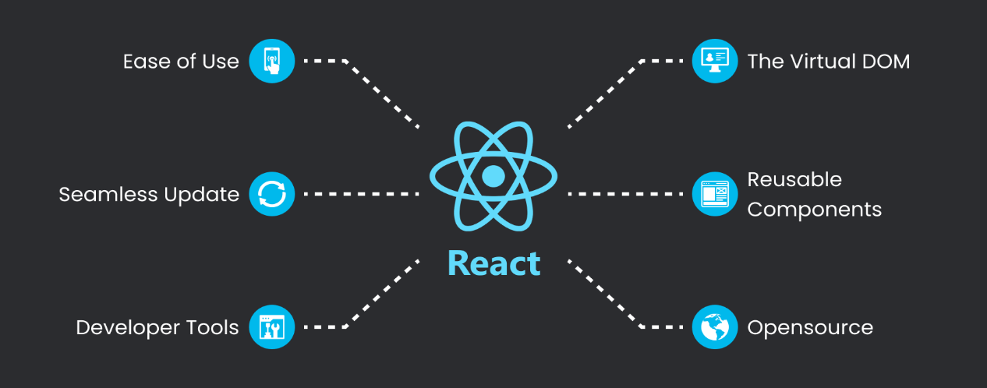ReactJS (often referred to as React) is an open-source JavaScript library for building user interfaces, particularly for single-page applications and reusable UI components. It was developed and is maintained by Facebook, and it has gained significant popularity within the web development community. [4]

Figure 4: Reactjs advantages

## **JSX**

JSX (JavaScript XML) is a syntax extension that allows you to write HTML-like code within your JavaScript. It makes it easier to define the structure and content of your components. [5]

Figure 5: JSX

## **Node.js**

Node.js is an open-source, cross-platform runtime environment that allows developers to execute JavaScript code on the server side. Traditionally, JavaScript was mainly used for front-end web development, running in browsers. However, Node.js extends the use of JavaScript to the server side, enabling developers to build scalable and high-performance applications. [6]

Figure 6: Node.js features

## **Flutter**

Flutter is a cross-platform framework developed by Google that allows you to build native interfaces for iOS and Android using a single codebase. It provides a rich set of pre-built UI components and libraries for building beautiful and responsive user interfaces. [7]

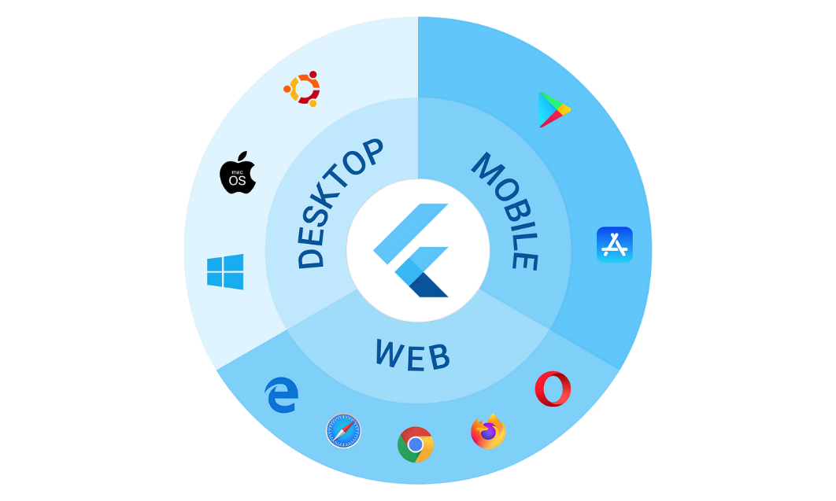

Figure 7: flutter platform

## **Dart**

Dart is the programming language used in Flutter development. It is an object-oriented, class-based language with C-style syntax. Dart is used to write the logic and functionality of the frontend application. [8]

## **UI/UX Design Tools**

To design the user interface of the frontend application, designers often use graphic design tools such as Adobe XD, Sketch, or Figma. These tools allow designers to create wireframes, prototypes, and visual designs that can be shared with the development team, **Figma** has been adopted for that.

## **Firebase**

Firebase is a Backend-as-a-Service (BaaS) platform developed by Google. It provides a set of tools and services that facilitate backend development, including authentication, real-time database, cloud storage, and cloud functions. Firebase can be integrated with Flutter to handle user authentication, data storage, and serverless functions. [9]

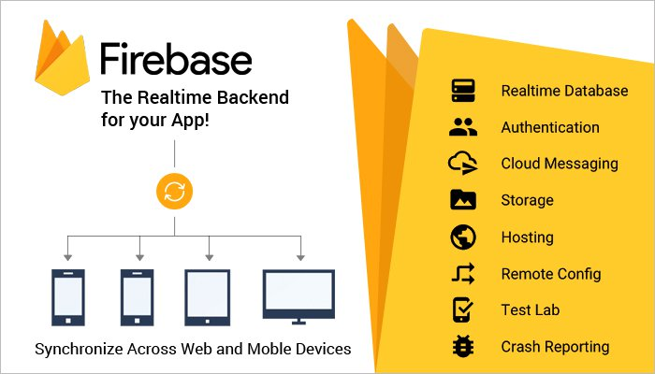

Figure 8: Firebase features

## **API Integration**

Many fronted applications require integration with external APIs to fetch data or interact with external services. For example. Flutter provides libraries and packages for making HTTP requests and handling API integrations. [10]

## **Testing Frameworks**

Testing is an integral part of software development to ensure the quality and functionality of the application. Flutter provides testing frameworks like Flutter Testing and Integration Testing for writing unit tests and integration tests to automate the testing process.

## **Performance Optimization**

Optimizing the performance of the front-end application is crucial to provide a smooth and responsive user experience. Techniques like code optimization, image compression, lazy loading, and caching can be employed to improve the application's performance.

**Used Technologies**

The IntelliGym platform leverages the latest in web and mobile technologies to deliver a seamless user experience. The website is built using Node.js and Express for server-side operations, React.js for the front-end, and Bootstrap for styling and responsive design.

Firebase provides the real-time database that powers the platform, ensuring that data is always up-to-date and accessible from anywhere. The mobile app is built using Flutter, Dart, and Firebase to provide a native, fast and user-friendly experience. Both the website and app have been designed to work in harmony with the real-time database, ensuring that the data is always in sync and providing users with a consistent experience regardless of the device they are using.

**UI/UX:**

The IntelliGym mobile application has put a lot of thought into the UI and UX design to ensure the best user experience. By following the six common UI design principles such as structure, simplicity, visibility, feedback, tolerance, and reuse, the app is able to provide an organized, clear, and user-friendly interface. All these design elements work together to create a professional and beautiful experience for the user.

# CONCLUSION

In conclusion, the IntelliGym mobile application aims to revolutionize the fitness industry by providing a comprehensive and convenient platform for users to track their progress, connect with top coaches and nutritionists, and stay on top of their fitness goals. With its innovative features such as QR code scanning, real-time session tracking, and a directory of nearby gyms, the IntelliGym app provides users with everything they need to achieve their fitness goals in one centralized place. Additionally, with its focus on security and ease of use, IntelliGym sets itself apart from its competitors and provides a unique and valuable solution for the modern fitness enthusiast. Overall, the IntelliGym project represents a major step forward in the world of mobile fitness and is poised to make a significant impact on the industry.

# REFERENCES

|  |  |
| --- | --- |
| [1] | classpass, [Online]. Available: https://classpass.com/. [Accessed 10 September 2023]. |
| [2] | Yoma, [Online]. Available: https://www.yomapp.com/. [Accessed 10 September 2023]. |
| [3] | "GetMuv," 1Pass, [Online]. Available: https://www.1pass.app/en. [Accessed 10 September 2023]. |
| [4] | A. Banks and E. Porcello, Learning React: Functional Web Development with React, New York: O’Reilly Media, 2018. |
| [5] | M. Thomas, React in Action, Greenwich: Manning Publications, 2018. |
| [6] | S. Stefanov, React: Up & Running: Building Web Applications, Bern, Switzerland: O'Reilly Media, 2021. |
| [7] | google, "Flutter: Build beautiful, natively compiled, multi-platform applications from a single codebase," [Online]. Available: https://flutter.dev/. [Accessed 31 August 2023]. |
| [8] | M. Pilgrim, Dart: Up and Running, O'Reilly Media, 2013. |
| [9] | Google, "Firebase | Google's Mobile and Web App Development platform," 2023. [Online]. Available: https://firebase.google.com/. [Accessed 31 August 2023]. |
| [10] | M. Biehl, RESTful API Design (API-University Series), CreateSpace Independent Publishing Platform, 2016. |